**Assignment 3**

**Question 1**

**Write a Python program to add two numbers using class and object.**

**(Take both numbers as input from the user)**

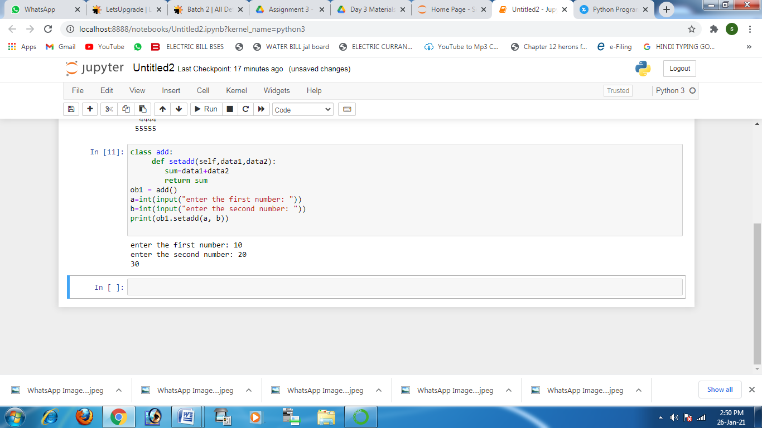

**Question 2 Define a function swap that should swap two values and print the swapped variables outside the swap function.**

